
"Remove not the ancient landmarks, which thy fathers have set."
-- Proverbs 22:28
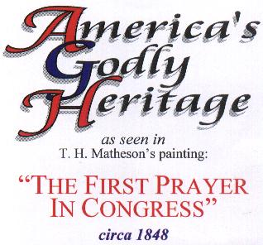
====================================
Presented by Charles A. Jennings
====================================
"Blow the trumpet in Zion, sanctify a fast, call a solemn assembly: ... Let the priests, the ministers of the LORD, weep between the porch and the altar, and let them say, Spare thy people, O LORD, and give not thine heritage to reproach, that the heathen should rule over them: wherefore should they say among the people, Where is their God?
-- Joel 2:15, 17
"The First Prayer in Congress" September 7, 1774
Carpenters' Hall, Philadelphia
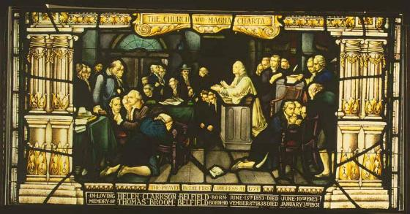
Stained glass and lead, from The Liberty Window, Christ Church, Philadelphia,
after a painting by Harrison Tompkins Matteson, c. 1848
Courtesy of the Rector, Church Wardens and Vestrymen of Christ Church, Philadelphia (101)
Credit: Religion and the Founding of the American Republic - Library of Congress
As recorded in the Journals of the Continental Congress the Rev. Mr. Jacob Duche, an Episcopal clergyman, was invited to open the First Congress with prayer which was held in Carpenters' Hall in Philadelphia, PA. The Rev. Mr. Duche first read Psalms 35 from the Psalter for the Seventh day of September, 1774, then proceeded to extemporaneously pray the following prayer:
"Be Thou present O God of Wisdom, and direct the counsel of this Honorable Assembly; enable them to settle all things on the best and surest foundations; that the scene of blood may be speedily closed; that Order, Harmony and Peace may be effectually restored, and that Truth and Justice, Religion and Piety, prevail and flourish among the people. Preserve the health of their bodies, and the vigor of their minds, shower down on them, and the millions they here represent, such temporal blessings as Thou seeth expedient for them in this world, and crown them with everlasting Glory in the world to come. All this we ask in the Name and through the merits of Jesus Christ, Thy Son and our Savior, Amen.


1 Cesar Rodney, Del.  2 Edward Rutledge, S.C.  3 T. Cushing, Mass.  4 Ephilet Dyer, Conn.  5 Samuel Adams, Mass.  6 John Adams, Mass.  7 Patrick Henry, Va.  8 John Rutledge, S.C.  9 George Washington, Va. | 10 Peyton Randolph, Va.  11 Col. N. Folsom, N.H.  12 Robert Treat Paine, MA  13 George Read, Del.  14 Silas Dead, Conn.  15 Richard Smith, N.J.  16 Philip Livingston, N.Y.  17 Thomas Lynch, S.C.  18 Stephen Hopkins, R.I. | 19 John Dehart, N.J.  20 William Livingston, N.J.  21 Thomas McKean, Del.  22 Roger Sherman, Conn.  23 William Paca, M.D.  24 Rev. Mr. Duche, Pa.  25 Samuel Rhodes, Pa.  26 Col. William Floyd, N.Y.  27 Stephen Crane, N.J. | 28 Samuel Chase, M.D.  29 John Morton, Pa.  30 Thomas Mifflin, Pa.  31 Charles Thomson, Va.  32 Rich. Henry Lee, Va.  33 John Jay, N.Y.  34 Isaac Low, N.Y.  35 Benjamin Harrison, Va.  36 Samuel Ward, R.I.
The Library of Congress from the collected reports of the various patriots,
records the effect of that first prayer upon Congress:
Washington was kneeling there, and Henry, Randolph, Rutledge, Lee, and Jay, and by their side there stood bowed in reverence, the Puritan Patriots of New England, who at that moment had reason to believe that an armed soldiery was wasting their humble households. It was believed that Boston had been bombarded and destroyed.
They prayed fervently "for America, for Congress, for the Province of Massachusetts Bay, and especially for the town of Boston," and who can realize the emotion with which they turned imploringly to Heaven for Divine interposition and - "It was enough" says Mr. Adams, "to melt a heart of stone. I saw the tears gush into the eyes of the old, grave pacific Quakers of Philadelphia."

